**Instruction:**

Complete all questions in **1 hour.**

1. Draw the logic diagram of the following gates using logsim and complete the

Truth tables.

1. AND

|  |  |  |
| --- | --- | --- |
| **A** | **B** | **A.B** |
| **0** | **0** | **0** |
| **0** | **1** | **0** |
| **1** | **0** | **0** |
| **1** | **1** | **1** |

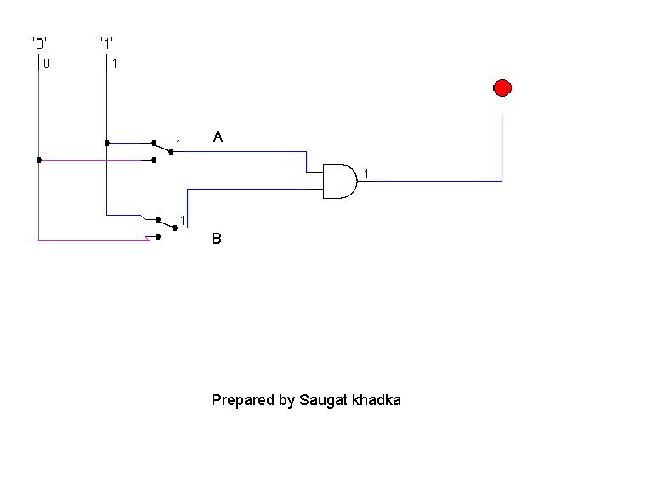

1. NOR (do the same as in Q No a for all of the following)

|  |  |  |
| --- | --- | --- |
| **A** | **B** | **(A+B )'** |
| **0** | **0** | **1** |
| **0** | **1** | **0** |
| **1** | **0** | **0** |
| **1** | **1** | **0** |

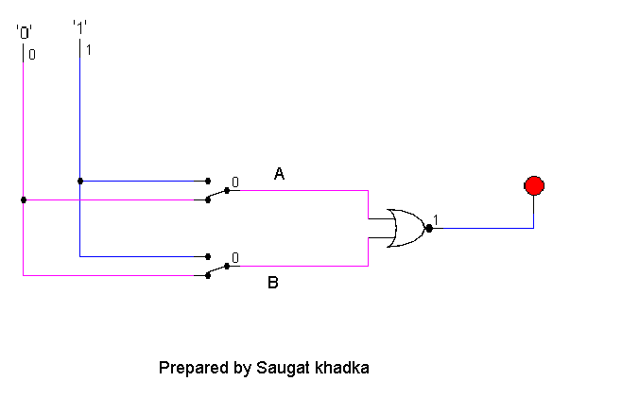

c)OR

|  |  |  |
| --- | --- | --- |
| **A** | **B** | **A+B** |
| **0** | **0** | **0** |
| **0** | **1** | **1** |
| **1** | **0** | **1** |
| **1** | **1** | **1** |

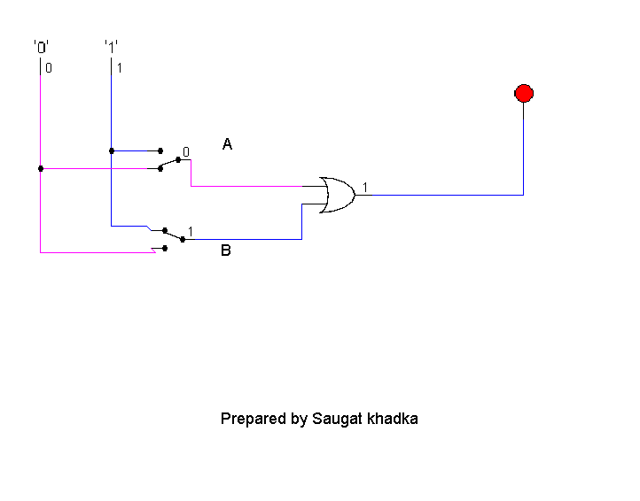

d)NAND (using NOT and AND)

|  |  |  |
| --- | --- | --- |
| **A** | **B** | **(A+B )'** |
| **0** | **0** | **1** |
| **0** | **1** | **1** |
| **1** | **0** | **1** |
| **1** | **1** | **0** |

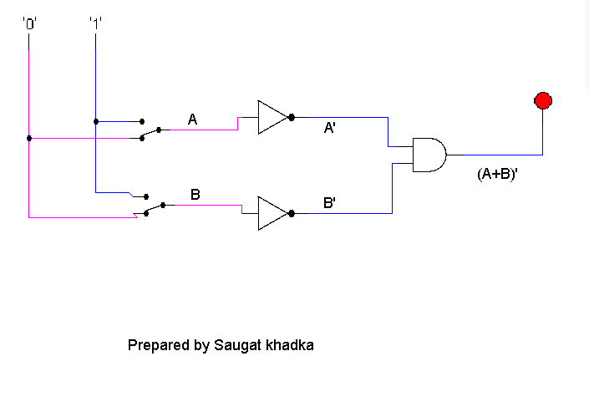

1. XOR using AOI

|  |  |  |
| --- | --- | --- |
| **A** | **B** | **A+B** |
| **0** | **0** | **0** |
| **0** | **1** | **1** |
| **1** | **0** | **1** |
| **1** | **1** | **1** |

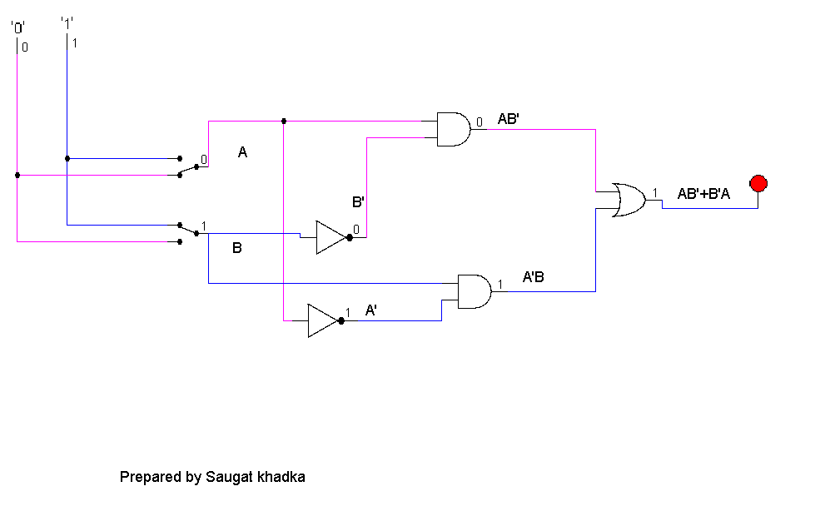

1. Use LogSim to build the equivalent circuit for the following Boolean equations.

Prove that the expressions are equivalent by computing truth table.

$$!\left(A+B\right)=!A.!B$$

|  |  |  |  |
| --- | --- | --- | --- |
| A | B | !(A+B) | !A . !B |
| 0 | 0 | 1 | 1 |
| 0 | 1 | 0 | 0 |
| 1 | 0 | 0 | 0 |
| 1 | 1 | 0 | 0 |

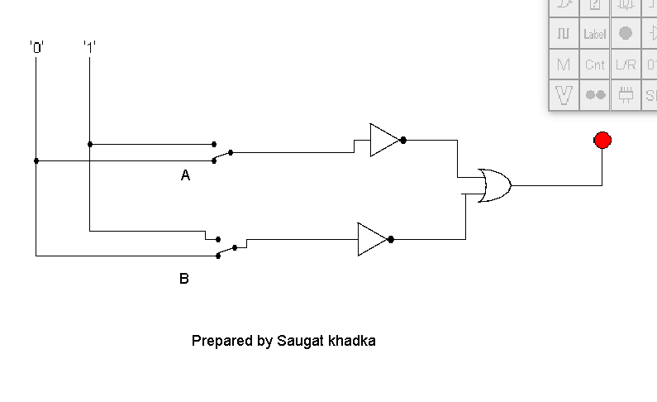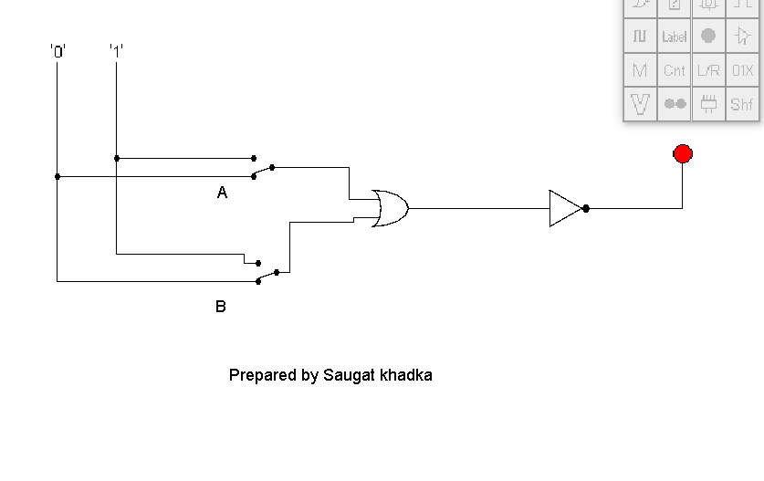

1. Draw the following circuit of half adder using LogSim.

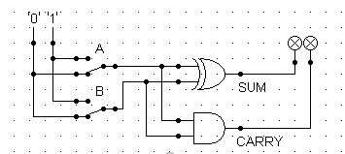

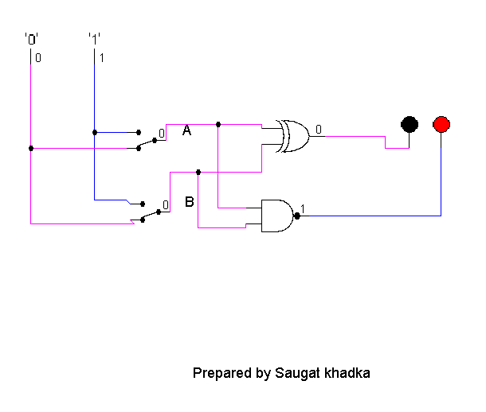

4.Draw full adder using Logsim and construct truth table.

|  |  |  |  |  |
| --- | --- | --- | --- | --- |
| A | B | Cin | sum | carry |
| 0 | 0 | 0 | 0 | 0 |
| 0 | 0 | 1 | 1 | 0 |
| 0 | 1 | 0 | 1 | 0 |
| 0 | 1 | 1 | 0 | 1 |
| 1 | 0 | 0 | 1 | 0 |
| 1 | 0 | 1 | 0 | 1 |
| 1 | 1 | 0 | 0 | 1 |
| 1 | 1 | 1 | 1 | 1 |

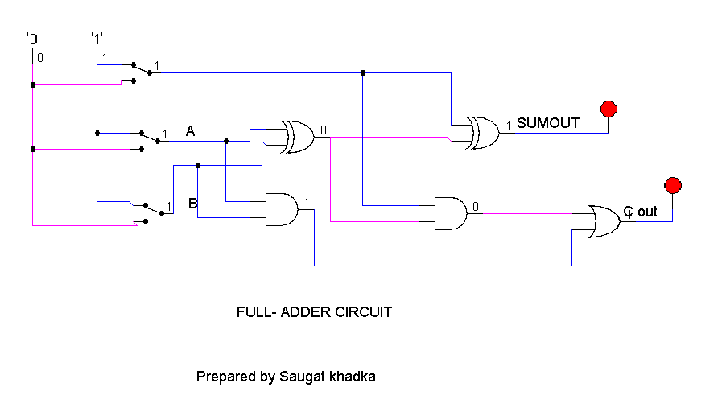

5.Draw the logic circuit for the following Boolean equations using logsim simulator.

* 1. AB+C

|  |  |  |  |  |
| --- | --- | --- | --- | --- |
| A | B | Cin | SUM | carryout |
| 0 | 0 | 0 | 0 | 0 |
| 0 | 0 | 1 | 1 | 0 |
| 0 | 1 | 0 | 1 | 1 |
| 0 | 1 | 1 | 0 | 1 |
| 1 | 0 | 0 | 1 | 1 |
| 1 | 0 | 1 | 0 | 1 |
| 1 | 1 | 0 | 0 | 1 |
| 1 | 1 | 1 | 1 | 1 |

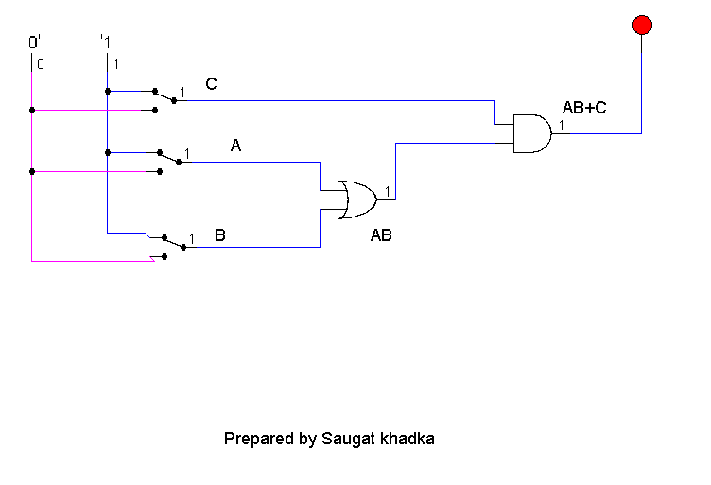

* 1. *A(B+C)*

|  |  |  |  |
| --- | --- | --- | --- |
| A | B | C | A(B+C) |
| 0 | 0 | 0 | 0 |
| 0 | 0 | 1 | 0 |
| 0 | 1 | 0 | 0 |
| 0 | 1 | 1 | 0 |
| 1 | 0 | 0 | 0 |
| 1 | 0 | 1 | 1 |
| 1 | 1 | 0 | 1 |
| 1 | 1 | 1 | 1 |

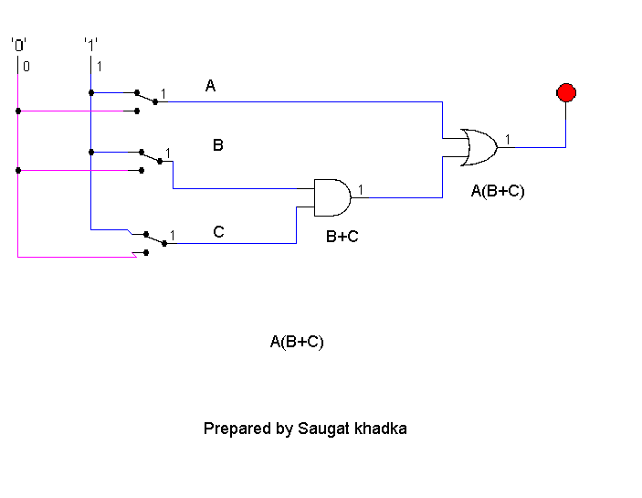

c.X’Y’Z’

|  |  |  |  |
| --- | --- | --- | --- |
| A | B | A'B+AB' | A.B |
| 0 | 1 | 1 | 0 |
| 0 | 0 | 0 | 0 |
| 1 | 0 | 1 | 0 |
| 1 | 1 | 0 | 1 |

